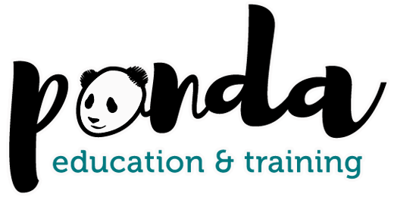

https://pandaeducation.co.uk/
Course and Qualification Portfolio

Assessor Qualifications:
- Certificate in Assessing Vocational Achievement (TAQA) Level 3 – Assessment in the workplace and workshop / classroom environment
- Award in Principles and Practices of Assessment (Level £) – knowledge / theory unit
- Award in Assessing Competence in the Workplace (Level 3) – Assessment in the Workplace
- Award in Assessing Vocationally Related Achievement (Level 3) – Assessment in the Classroom /workshop environment
- Certificate in Learning and Development Level 3

Internal Quality Assurance Qualifications:
- Award in Internal Quality Assurance of Assessment Process and Practice Level 4
- Award in Principles and Practices of IQA Level 4
- Certificate in Leading IQA of Assessment Process and Practices Level 4
Professional Development Workshops
- Supporting your learners’ wellbeing: A Communication Toolkit
- Reflective Practice
- Feedback for Progression
- Questioning Techniques to Stretch and Challenge
- Planning Learning Sessions
- Planning and Target Setting for Individuals
- Dealing with Difficult Learners
Teaching and Training Qualifications
- Training Skills Level 3
- Award in Education and Training Level 3
- Certificate in Learning and Development Level 3

For more information, please contact us in one of the following ways:
Tel. 029 21679037 E-Mail hello@pandaeducation.co.uk Enquiry Form

